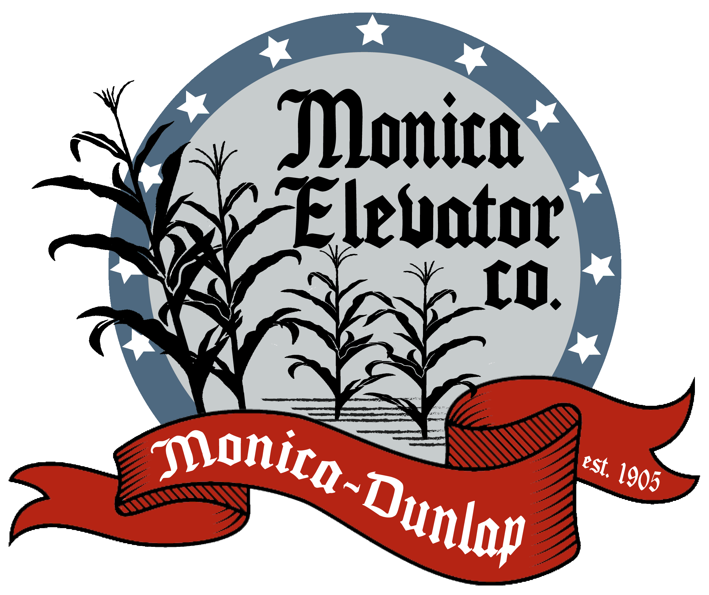
2022-2023 Fall Policy

Corn:
Open Storage and Price Later Storage Rates: 11 cents per bushel in charge, then 3 cent a month charged @ 1/10 cents/bu/day though August 31, 2023. Charges will be accrued and deducted from the sale.
Corn Drying:
15.1-16% | $.04/bu | 23.1-24% | $.22/bu
16.1-17% | $.08/bu | 24.1-25% | $.23/bu
17.1-18% | $.12/bu | 25.1-26% | $.24/bu
18.1-19% | $.14/bu | 26.1-27% | $.26/bu
19.1-20% | $.16/bu | 27.1-28% | $.28/bu
20.1-21% | $.18/bu | 28.1-29% | $.29/bu
21.1-22% | $.20/bu | 29.1-30% | $.30/bu
22.1-23% | $.21/bu | 30%+ | $.03/bu/point additional

Corn Sold will be shrunk 1.35% per 1% of moisture to 15
Corn on Open Storage and Price Later will be shrunk 1.35% per 1% of moisture to 14
5 cent in charge on corn put on stored bushels under 15%

Beans:

Open Storage or Price Later Storage Rates: 14 cent in charge, then 1/10 cents/bu/day or 3 cents/bu/month until August 31, 2023.
Beans will be averaged by farm 15% and below, if there is a long break between start and finish, we will average by the week
Bean shrinkage of 1.5% per ½% of moisture from 13.00 - 14.99%
Bean shrinkage of 2% per ½% of moisture over 15 – 16.99%
Bean shrinkage of 2.5% per ½% of moisture above 17%. Beans above 17% are subject to rejection.
Please call before delivering wet beans over 17% as we will do our best to be able to work with customers.

Grain delivered will be applied to contracts before being placed in storage.

Test weight
Corn |  | Beans
53.9-50 lbs | $.01/bu/lbs | 53.9-50 lbs | $.02/bu/lbs
49.9-46 lbs | $.02/bu/lbs | 49.9-48 lbs | $.03/bu/lbs
45.9-0 lbs | $.04/bu/lbs | 48 lbs – 0lbs | $.04/bu/lbs
Foreign Material
Corn |  | Beans
3.1%-5% | $.02/bu/% | Deduct 1/10% for each 1/10th of a point over 1%
5.1%-10% | $.03/bu/% | Ex. 1.1%=.1% 2.0% = 1.0%
10% + | $.04/bu/%
Damage
Corn |  | Beans
5%-7% | $.02/bu/% | 2.1%-4% | $.02 each ½ pt
7.1%-15% | $.03/bu/% | 4.1%-6% | $.03 each ½ pt
15.1%+ | $.04/bu/% | 6.1% + | $.04 each ½ pt
Other Charges
Corn |  | Beans
Musty | $.05/bu | Musty | $.10/bu
Sour | $.10/bu | Sour | $.15/bu
COFO | $.12/bu or Rejection | Heat Damage | $.03 per ½ pt/bu from .02%+
Rocks | $.15/bu or Rejection | Splits | $.02/bu/1% over 20%
Infested | $.15/bu or Rejection | Infested | $.15/bu

Grain Quality – Monica Elevator reserves the right to refuse grain because of quality factors.
Grain Bids – Monica’s bids are subject to change at any time. Please note that a price quote is not a sale; a specific quantity, price and delivery period are needed. Verbal agreements are considered binding.
Contracts – We offer forward price fixed, basis fixed, HTA, and price later contracts. Please return a sign contract as soon as possible. This helps protect both Monica Elevator and the customer.
Out Charges: 6 cents on corn per bushel and 9 cents on beans per bushel will be charged to grain hauled out and not sold through Monica Elevator. Quality discounts will be charged or credited to customer’s account.
Fall Trucking Rates:
0 - 10 miles $ 0.11
11 - 15 miles $ 0.12
16 - 20 miles $ 0.13
21 - 25 miles $ 0.14

Please contact the Grain Office with any questions (309) 385-4938.

Monica Elevator reserves the right to change grain policy at any time based on market conditions. Policy changes will be posted at locations as well as on the website.

Thank you for your Business!

